**ASSIGNMENT 3:**

Create 3 repositories having an individual index.html file in each repository.

You have a httpd server installed on your Jenkins Master.

Create 3 Jenkins jobs, now whenever you commit any changes to any repository, index.html of that particular repository gets deployed on httpd server.

**Step 1:** Installed git and Apache Tomcat with Jenkins.war on ec2 Linux server. Also created 3 local git repositories- repo1, repo2, repo3 on server.

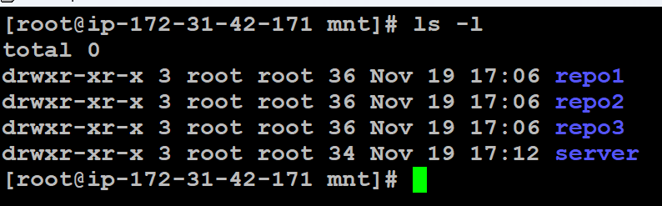

**Step 2:** Also have 3 GitHub repositories for repo1, repo2, repo3

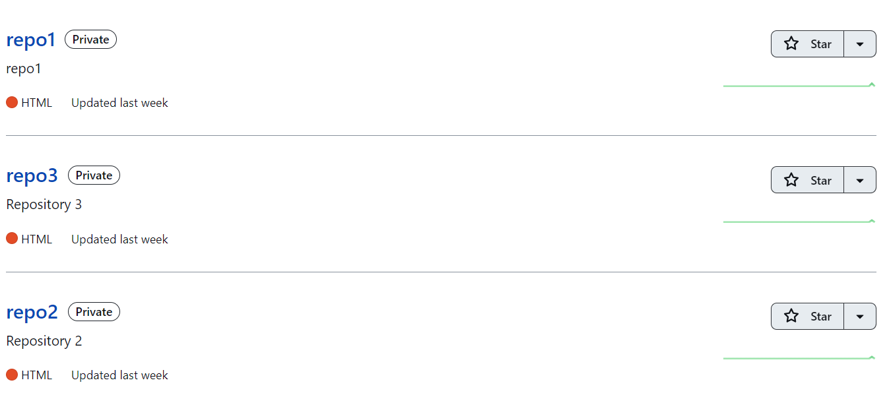

**Step 3:** Created 3 Pipeline jobs (repo1-job, repo2-job, repo3-job) with below configuration:

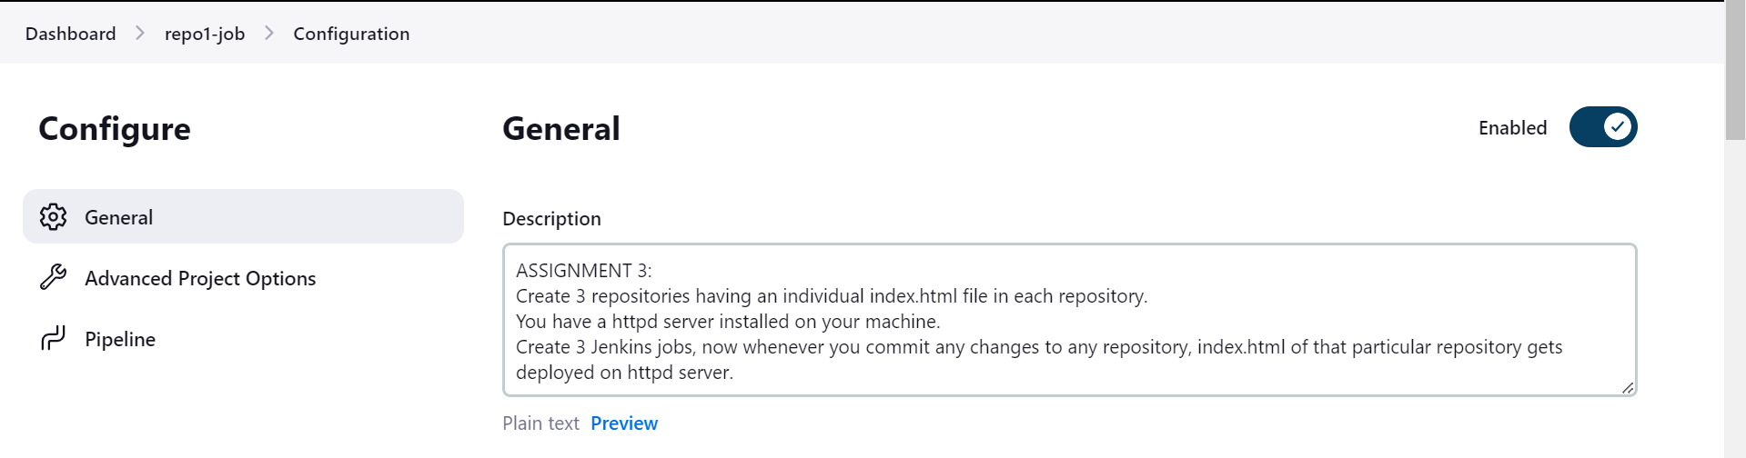

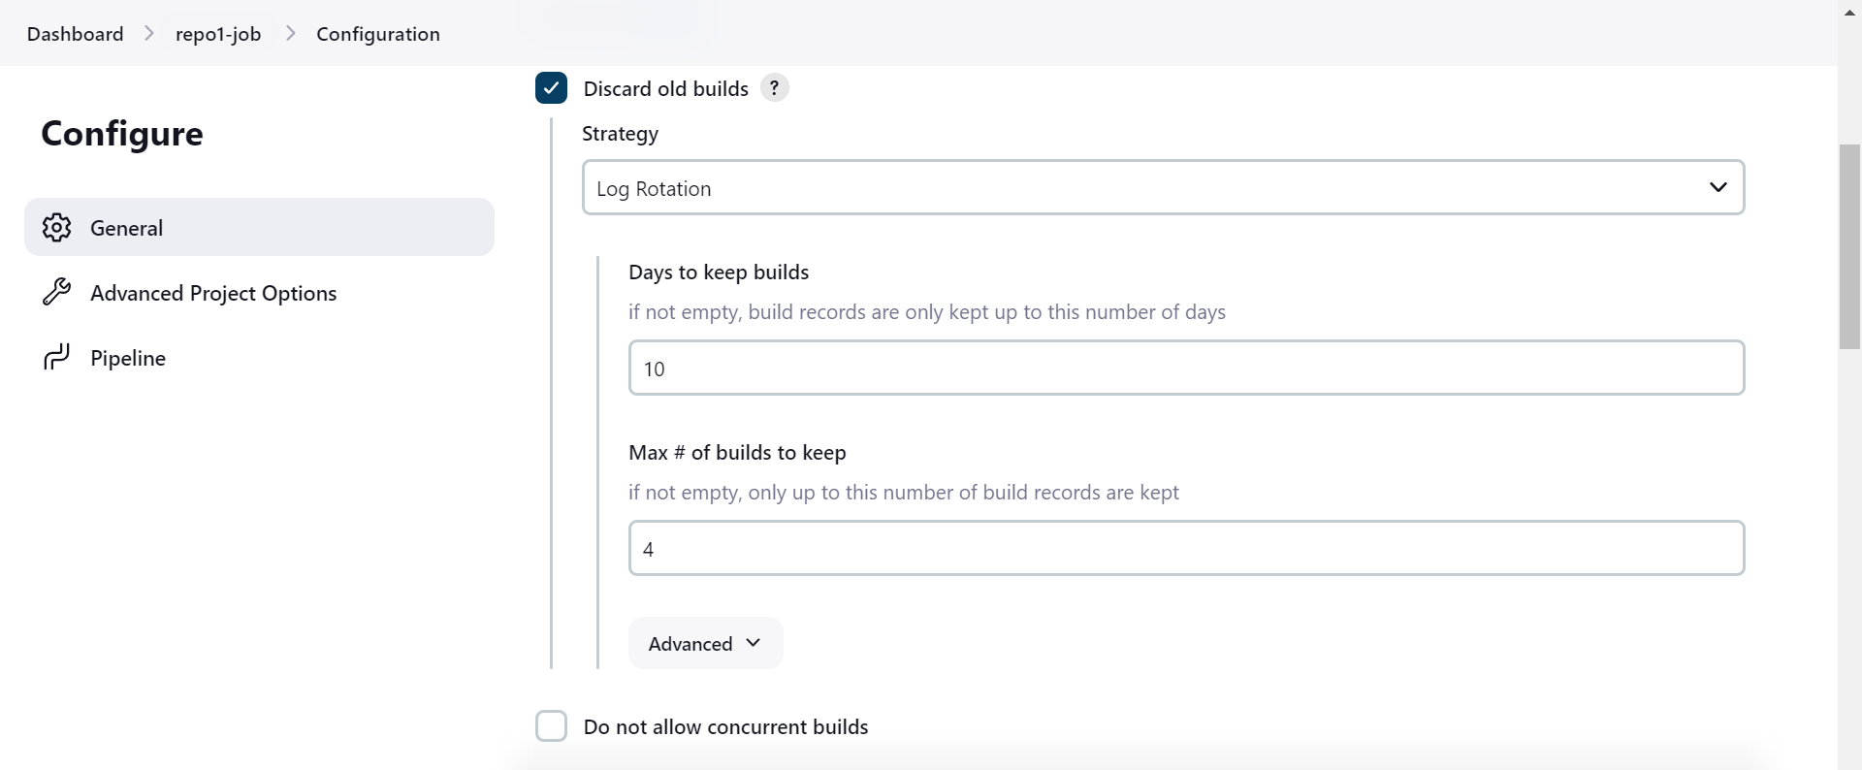

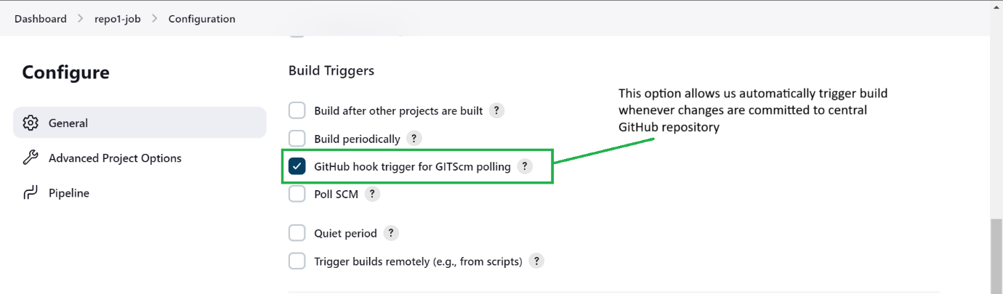

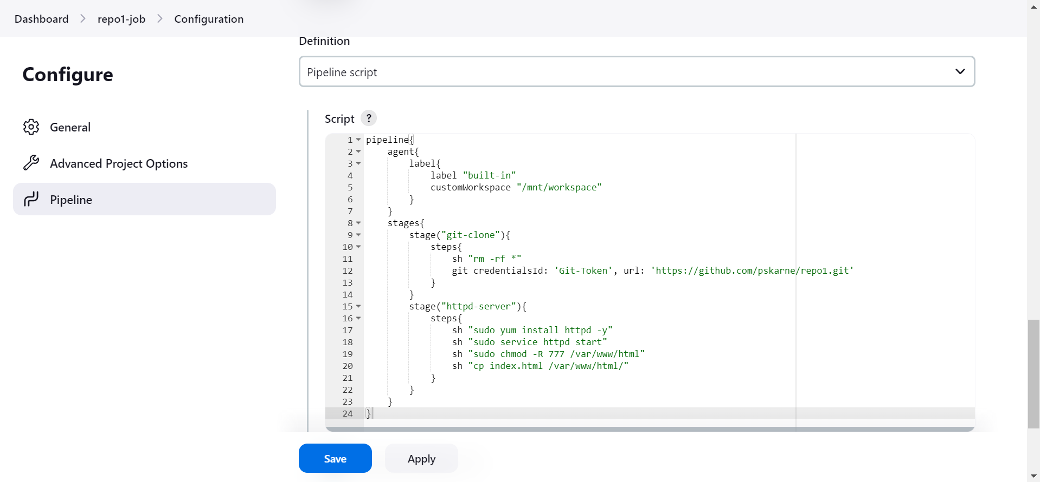

**Step 4:** Successfully created and build all three jobs.

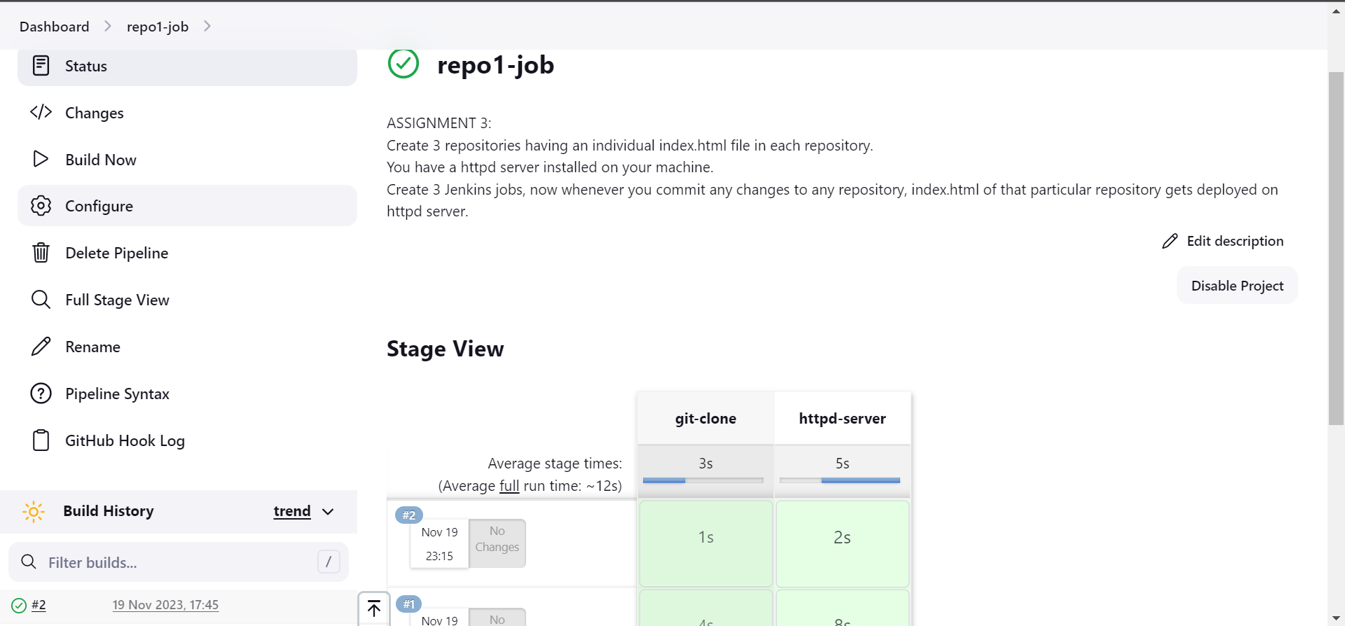

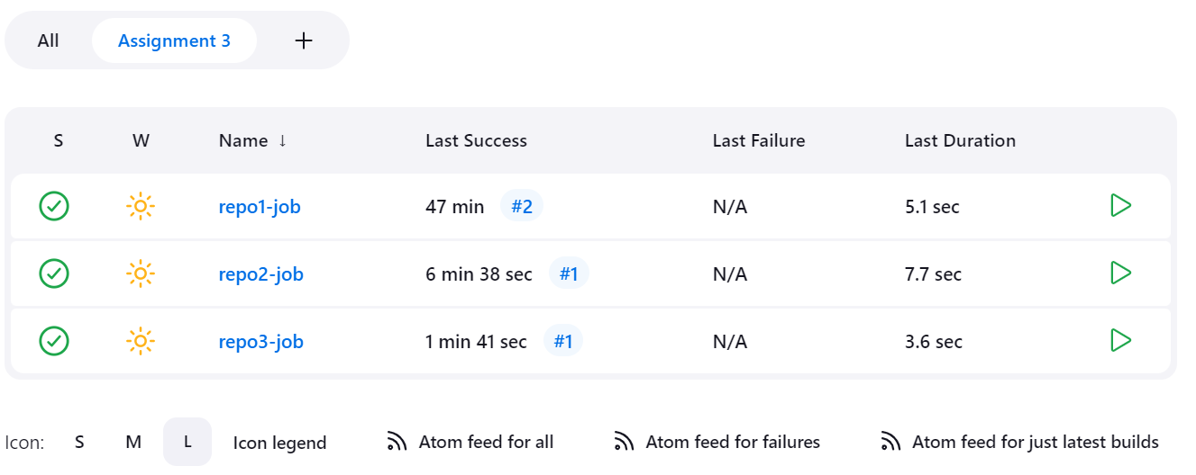



**Step 5:** Configured GIT Webhook Trigger on GitHub repository for

For that configured git hub server on Jenkins by going to:

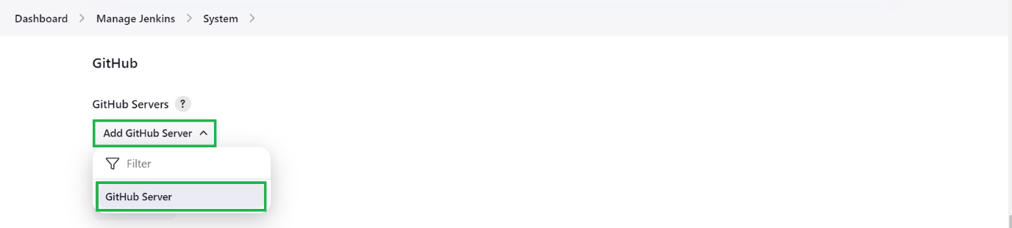

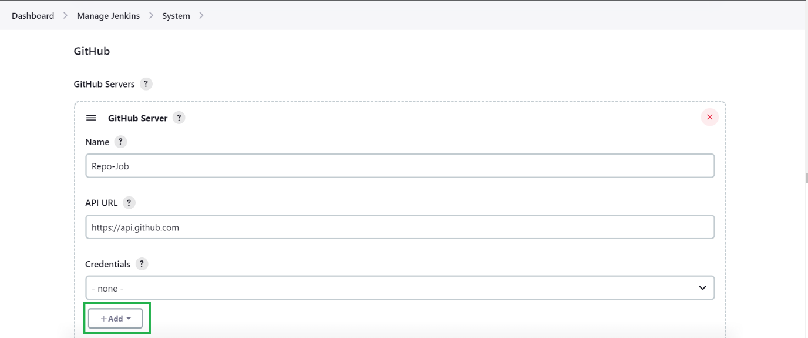

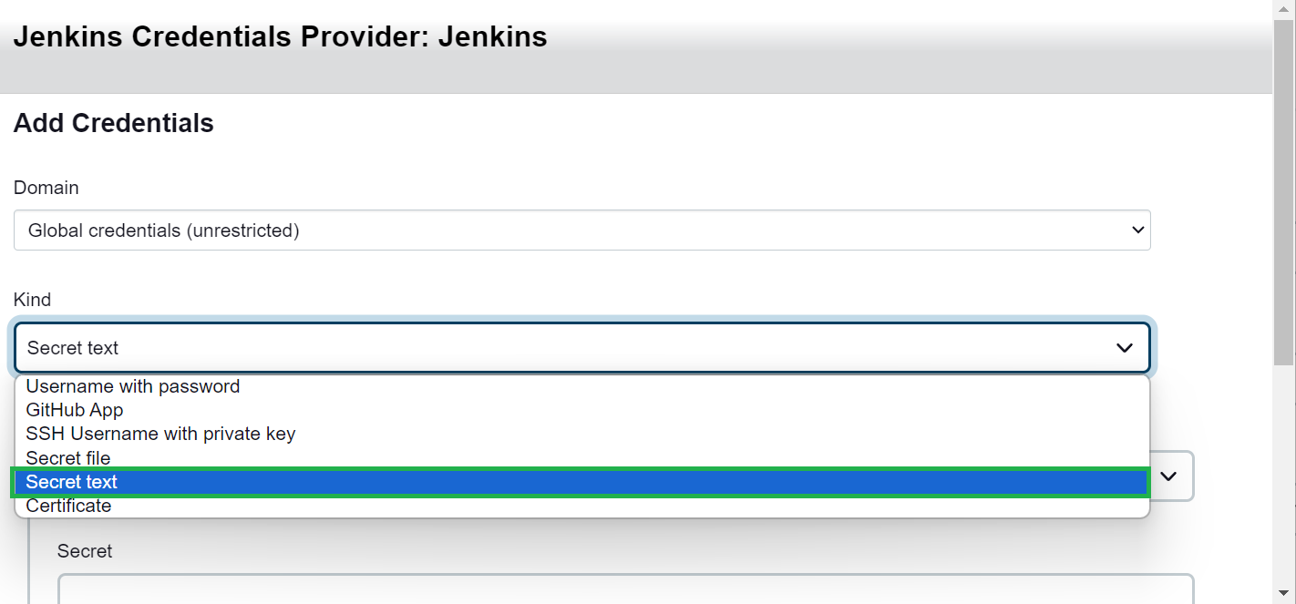

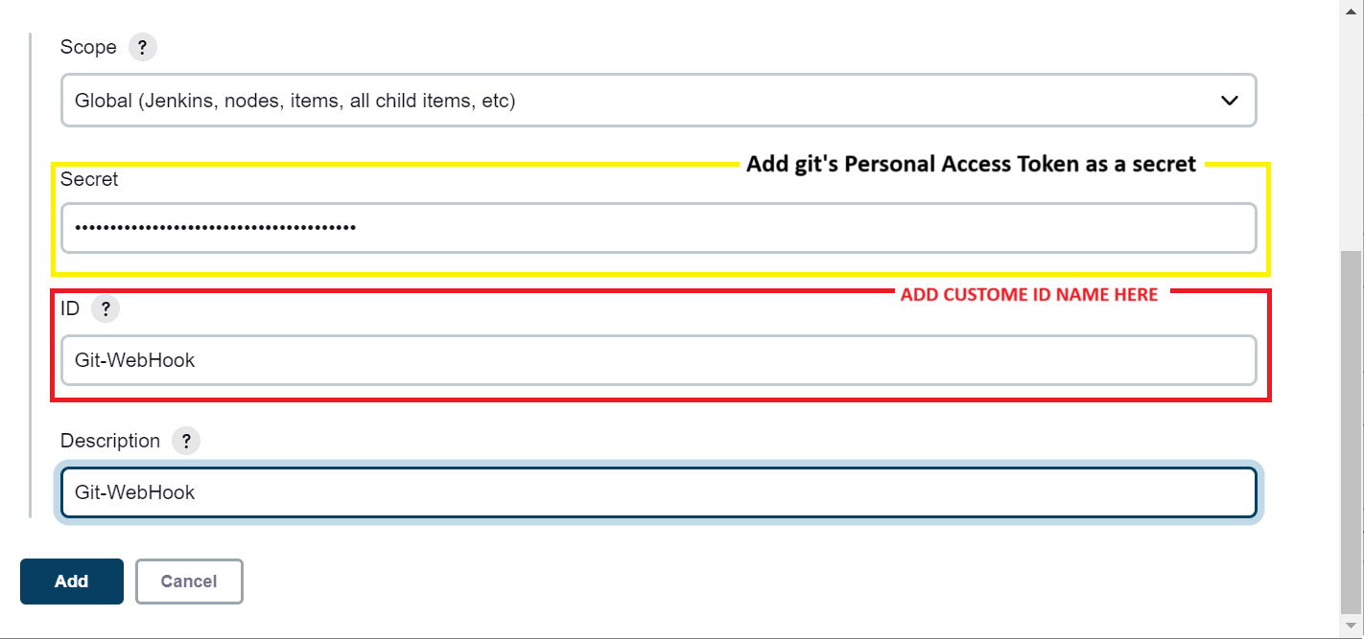

Selected the credentials and clicked on Test connection successfully.

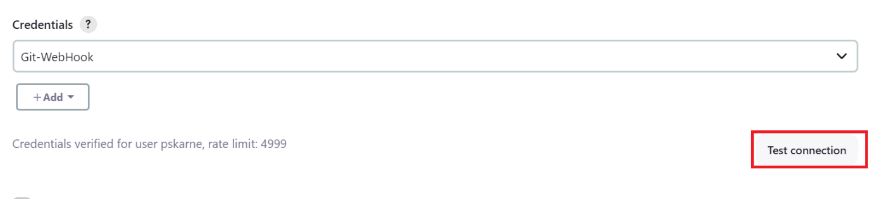

**Step 6:** GitHub Repository sides settings for Git Webhook Triggers for all three jobs:

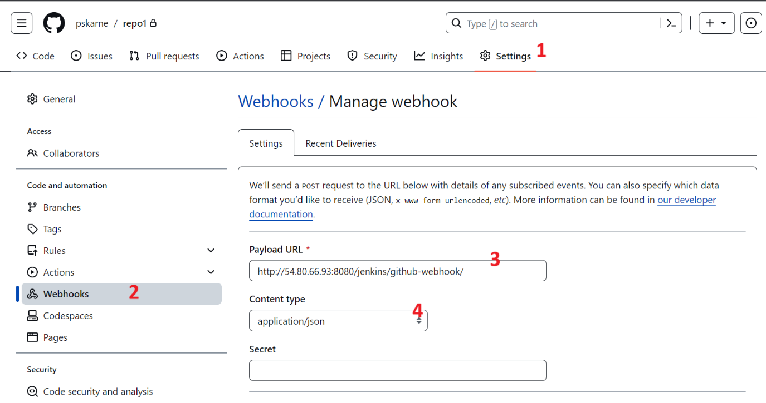

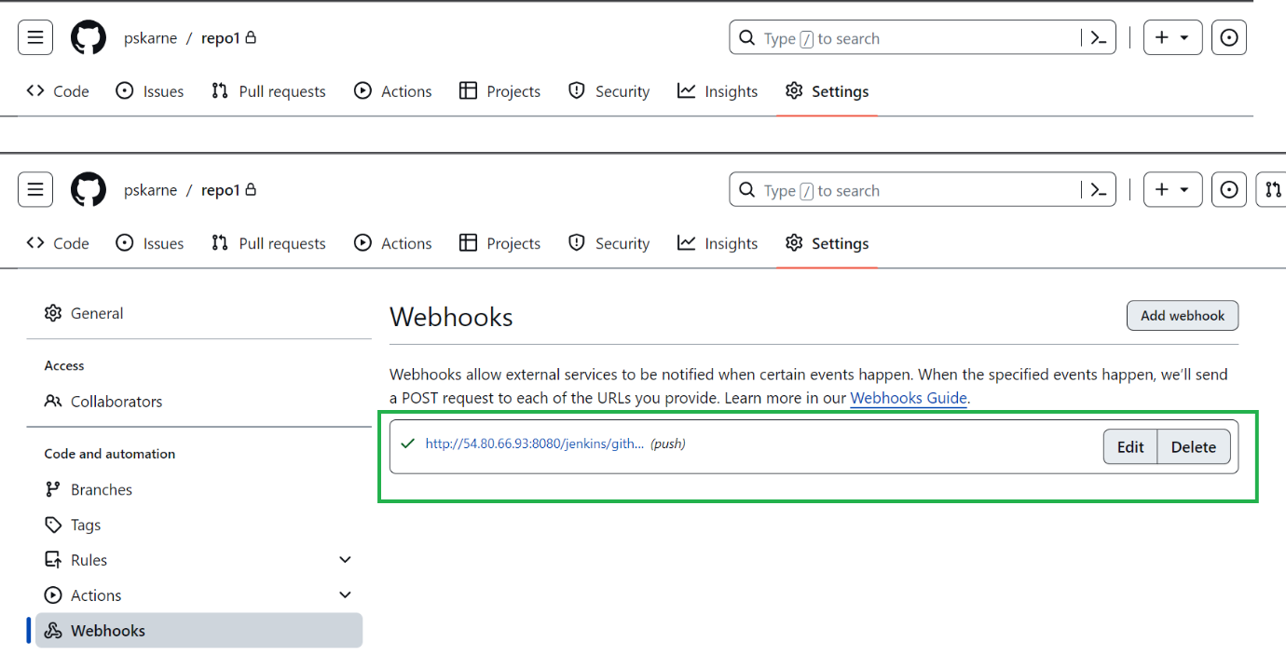

**-: TESTING :-**

Default output after building all three jobs manually one by one:

repo1-job- build output: (manually run the job)

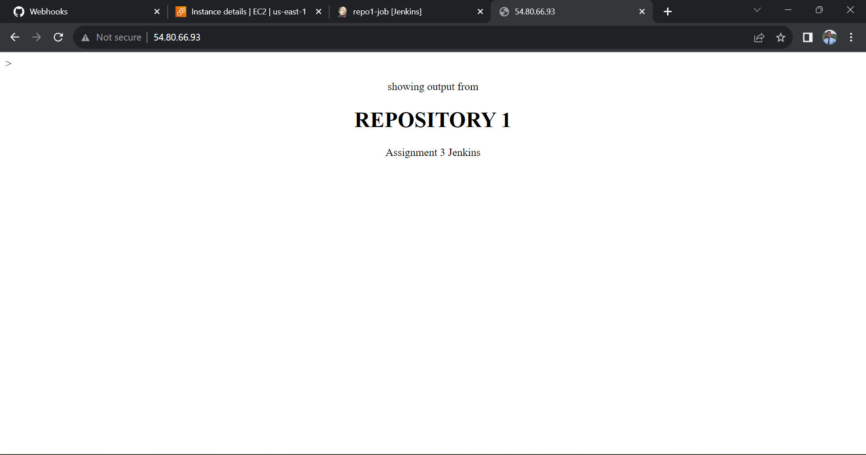

repo2-job build output: (manually run the job)

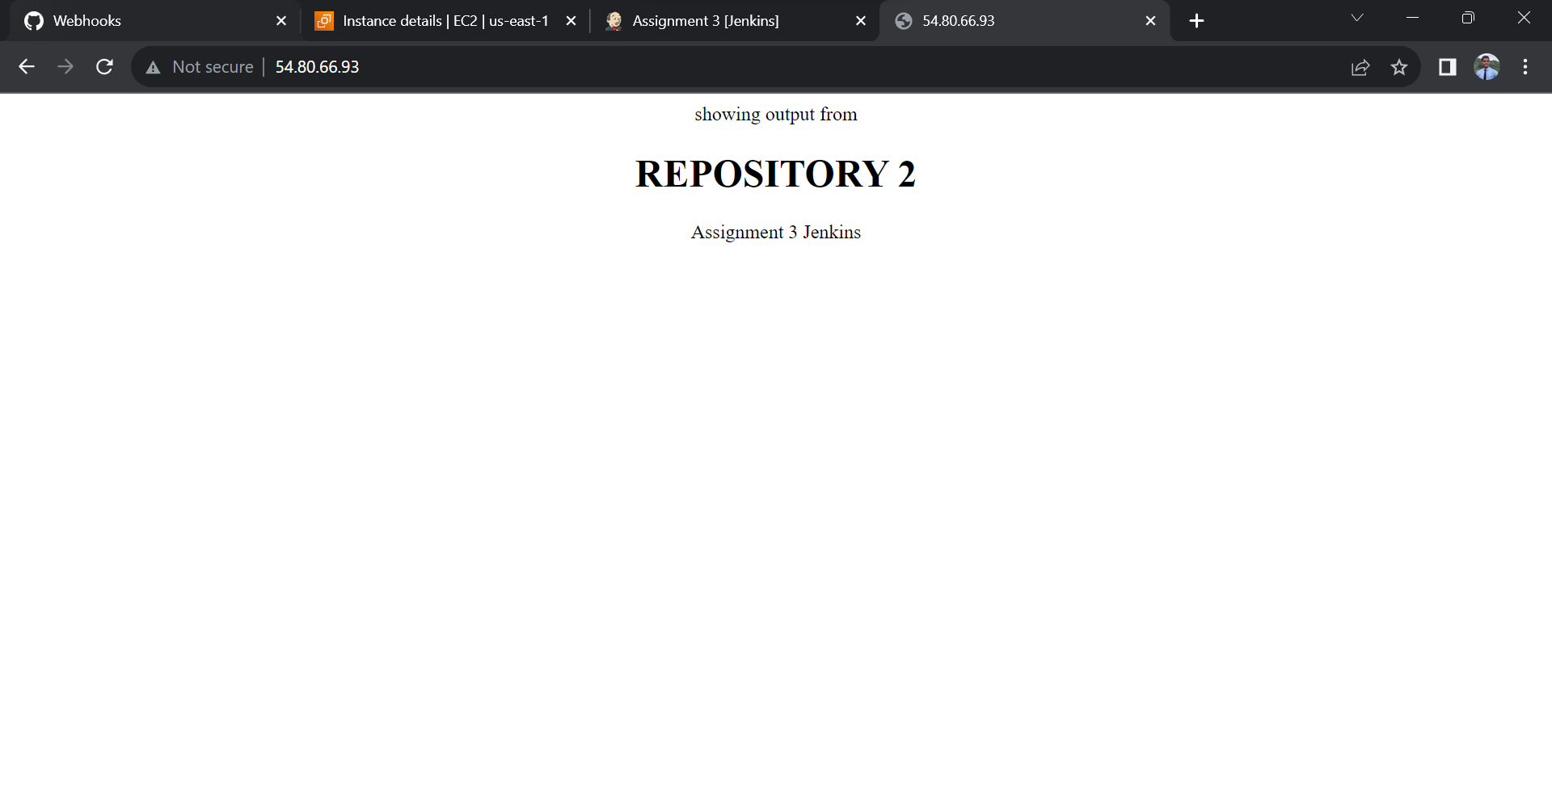

repo3-job build output: (manually run the job)

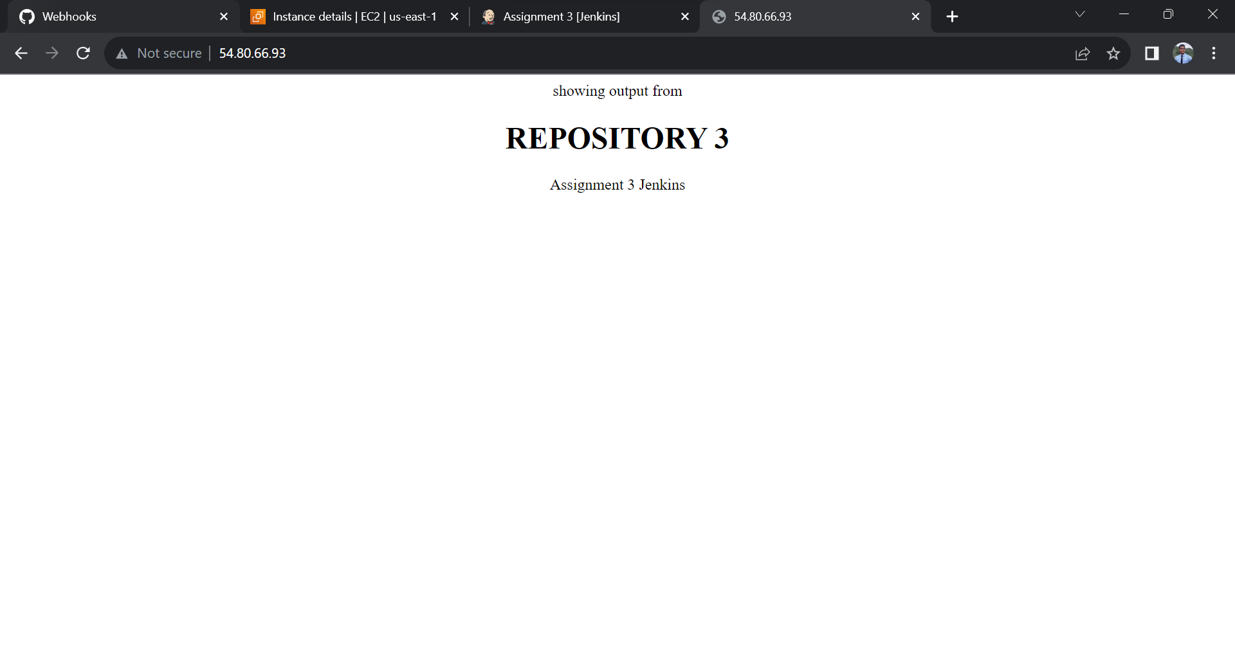

**-: FINAL OUTOUT :-**

1. Output when some changes pushed to GitHub- repo1:

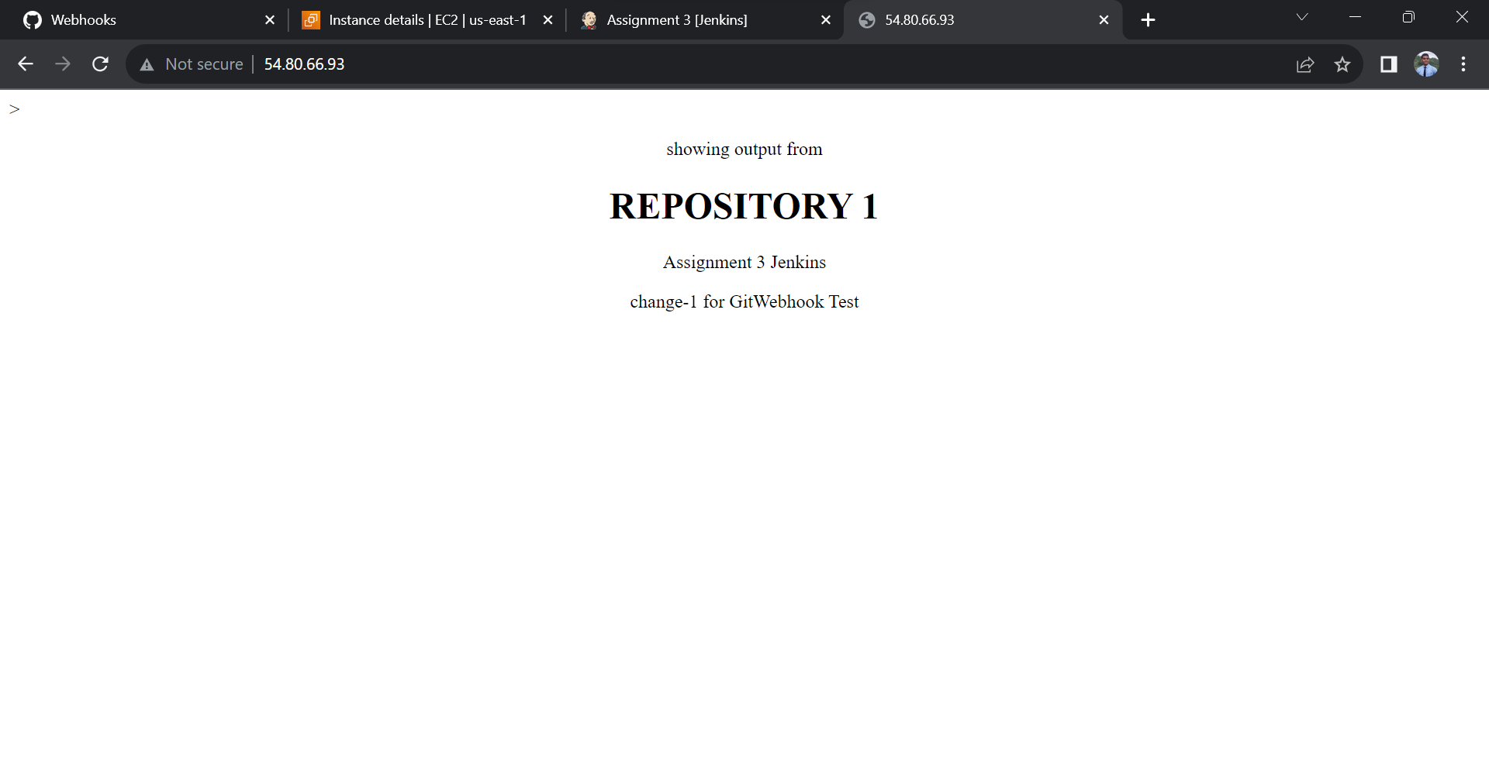

1. Output when some changes pushed to GitHub- repo2:

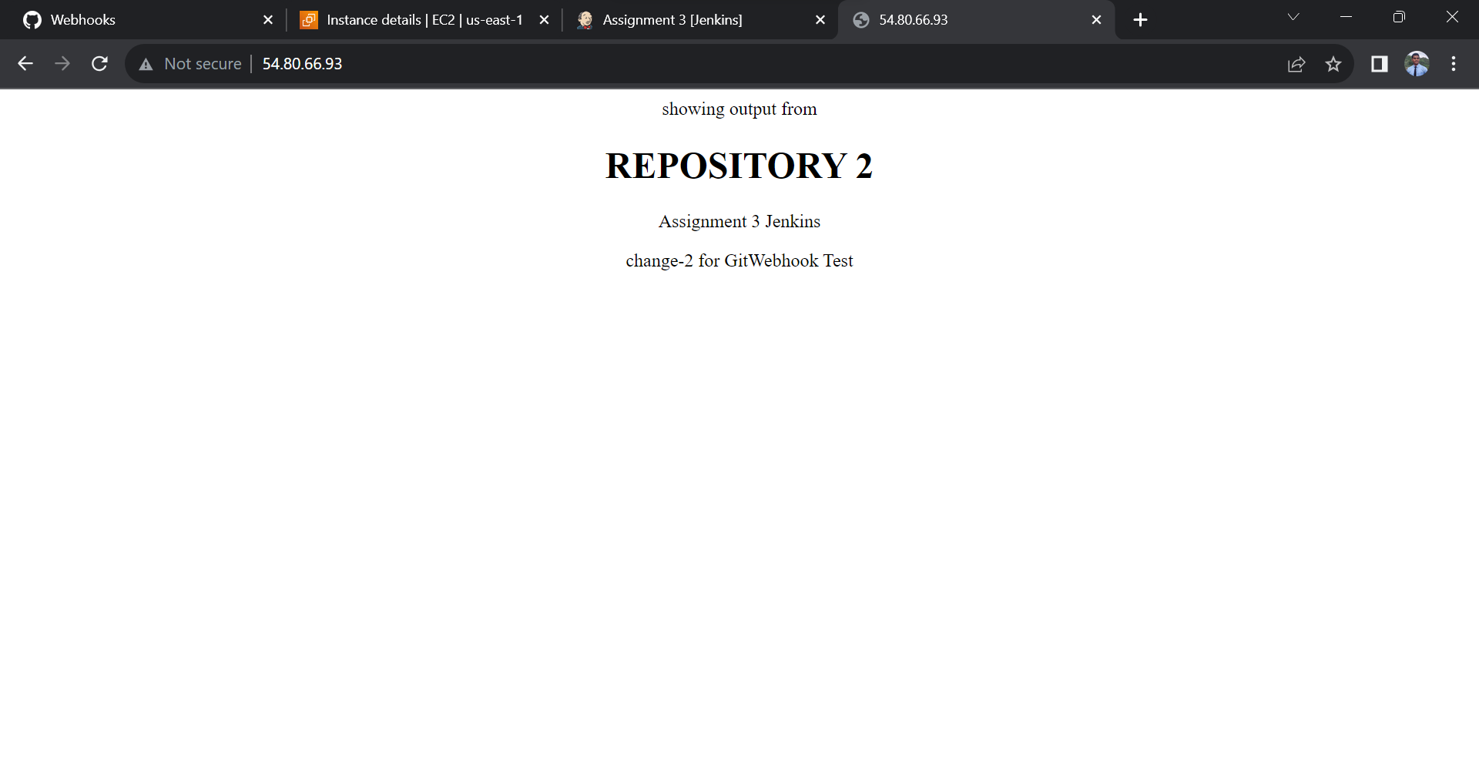

1. Output when some changes pushed to GitHub- repo3:

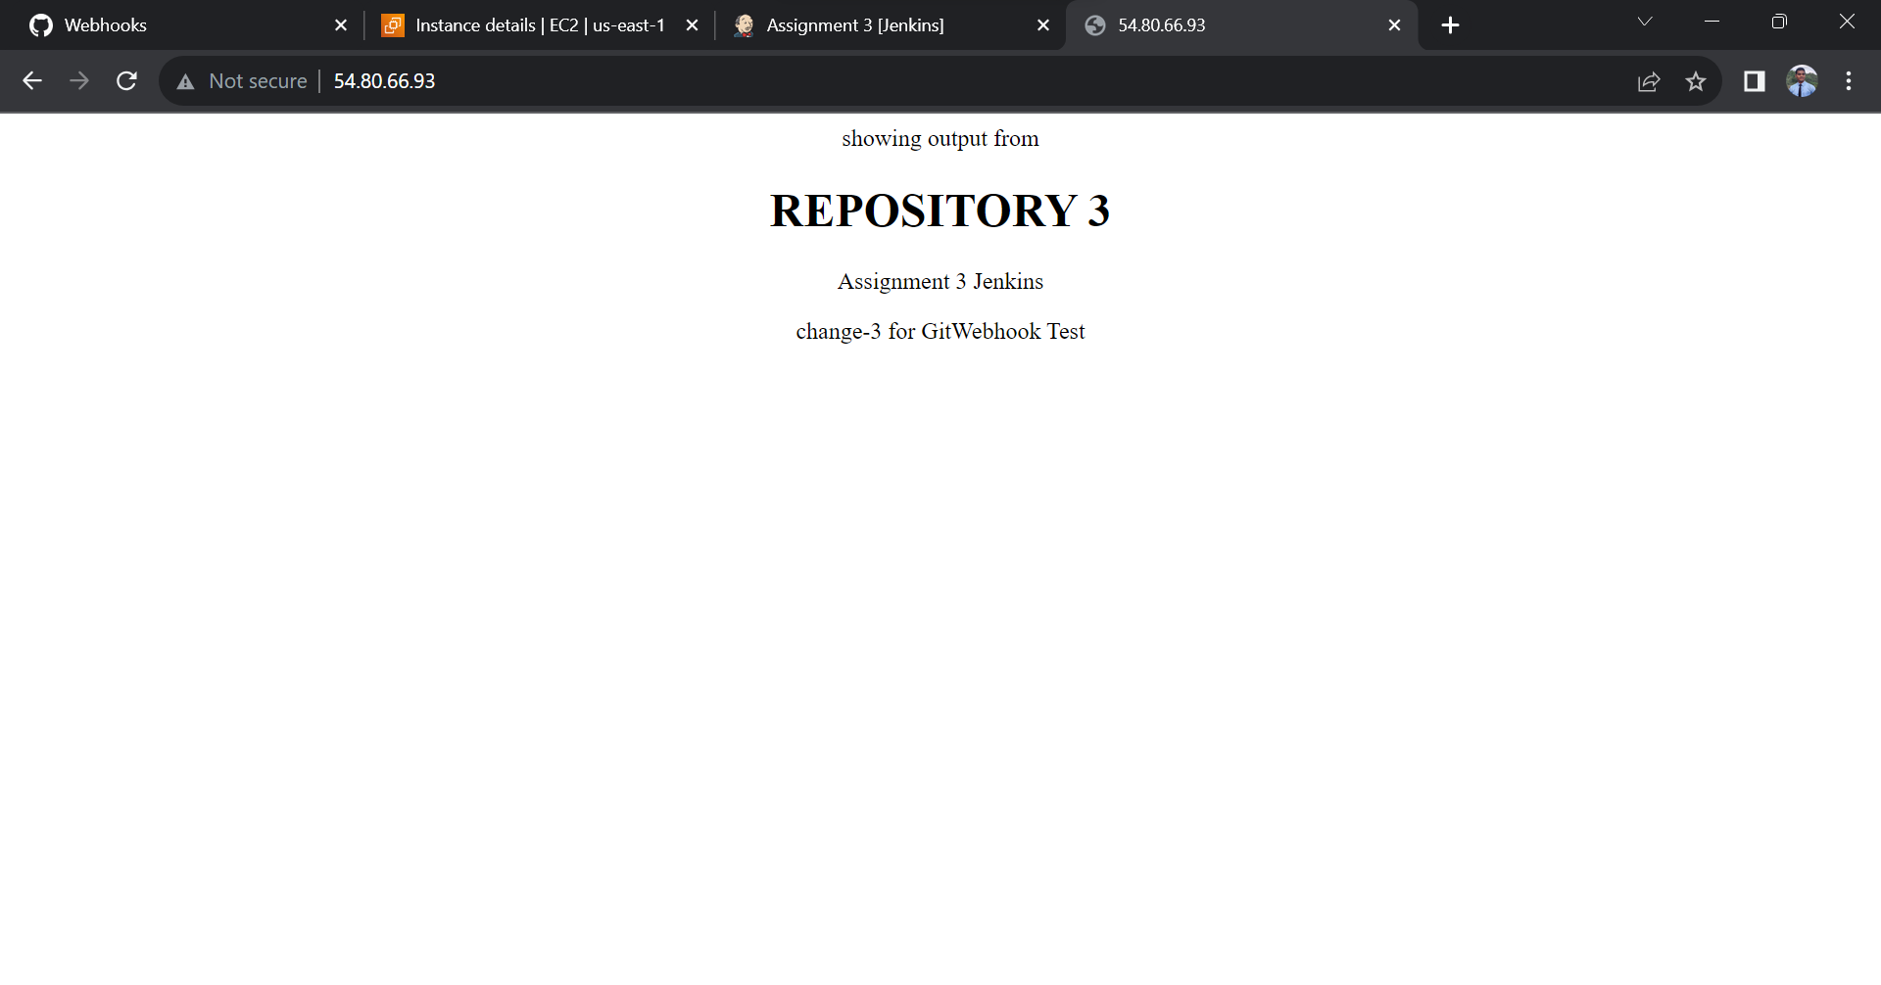

All the jobs are automatically triggering as soon as any changes are made to GitHub’s repository